Mesa Convention Center
Mesa Amphitheatre
263 N. Center Street
Mesa, Arizona 85201
(480) 644-2178
Meetings@mesaaz.gov
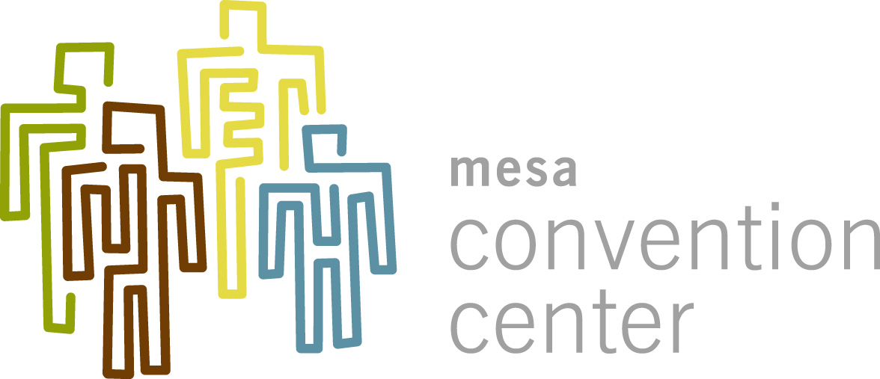



Area View

