Utilizing your profile as an SGRA Buyer
on the new SGRA website

Profile Picture
You have access to setting a profile picture for yourself. This will be visible on your profile page, and on our new rep search feature.
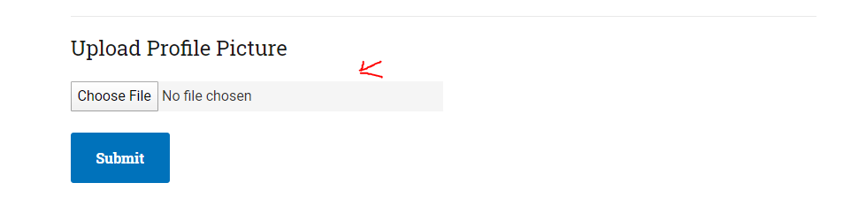
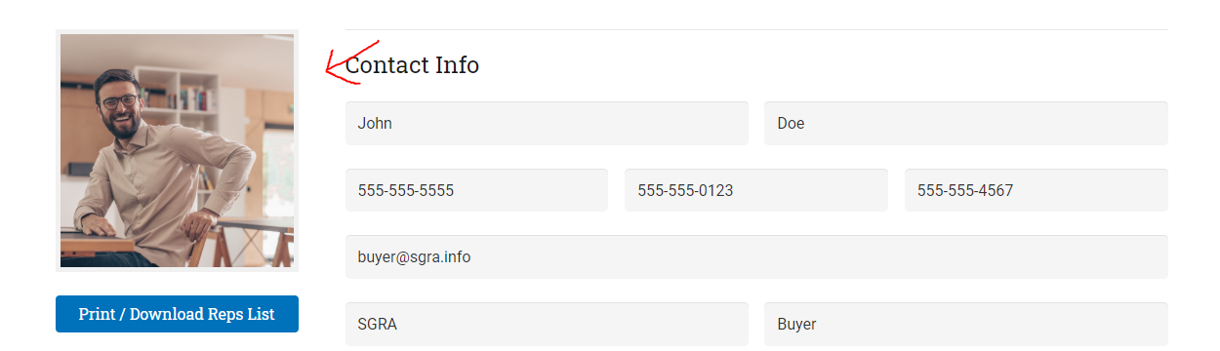
Contact Info
Update basic contact info here
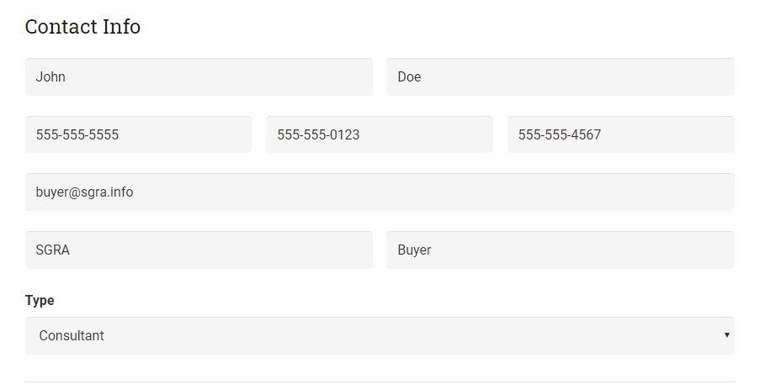

Address
Place your business address here
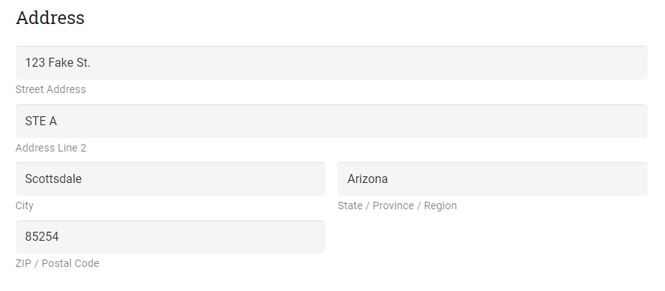

Quick Links for Convenience
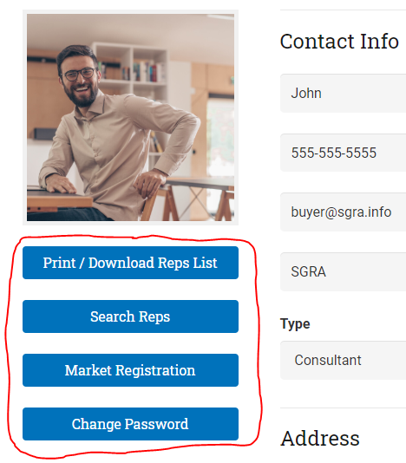

Downloading SGRA Reps list
You have access to our database of SGRA Reps as a downloadable file. Here you will find a printout of all of our SGRA Rep contact information.

Searching for SGRA Reps
Search our SGRA Reps by company, product type, first and last name, and by general keywords for all other information.

Registering for an SGRA Market
Utilize this link to find a quick link to our buyer’s registration form for the upcoming SGRA Market.

Change Password
Utilize this button anytime you need to change your password.

